ALL ADDITIONAL TEST CASES

Test Case | Expected Outcome | Result
1. Valid User Login (Staff) | Successful login and System displays the Staff Menu | Successful Login:  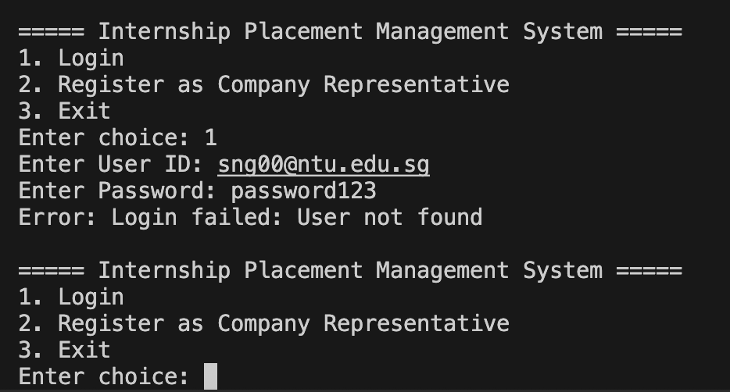
2. Invalid ID | If user enters an incorrect userId, an error message “User not found is displayed” | 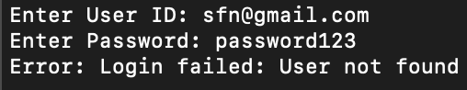
3. Incorrect Password | If the user enters an incorrect password, an error message “Incorrect Password” will be displayed instead | 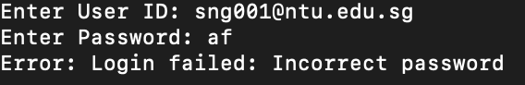
4. Password Change  Functionality | User is allowed to change their password and login through their new password | 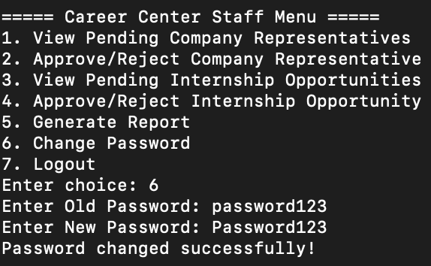  Allow login through new password  (password123 -> Password123)  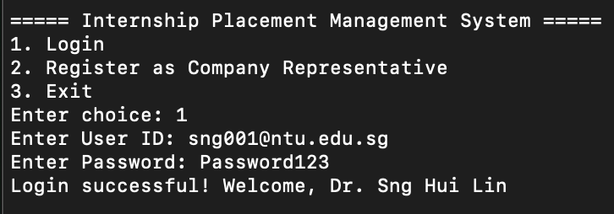
5. Company Representative  Account Creation | Company Representative is allowed to create an account and after approval, they will be able to log in to their new account | Create Account  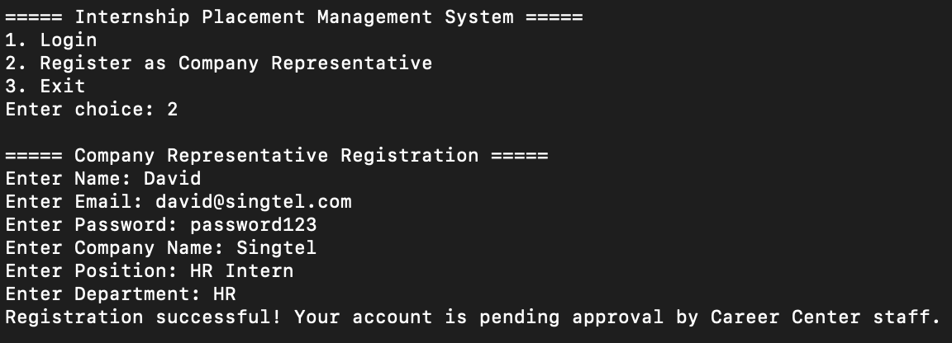  Staff Approve  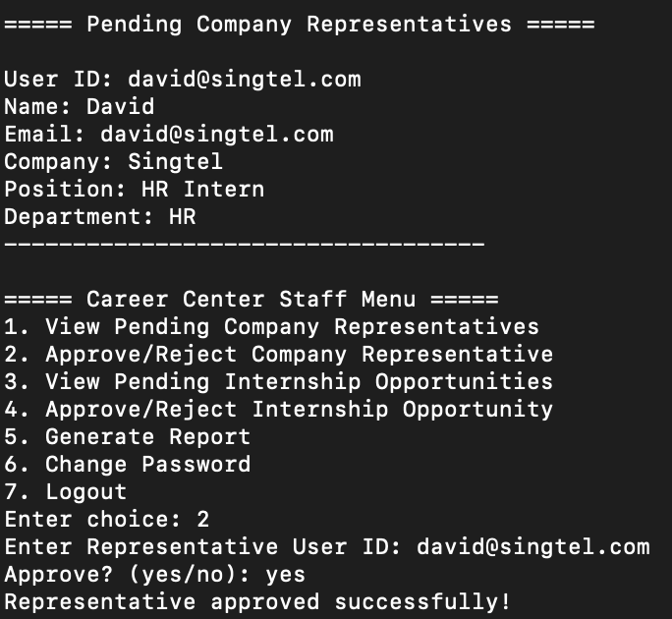  Rep Logs in  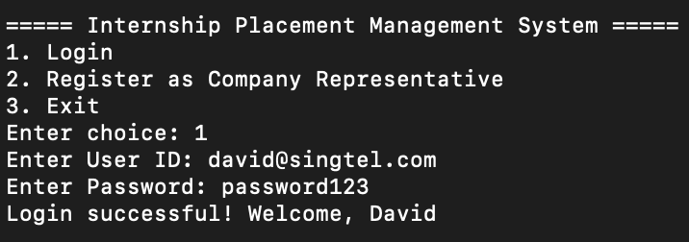
6. Internship Opportunity  Visibility Based on User  Profile and Toggle | View internship opportunities which are made available to the students based on their profile | Toggled Off  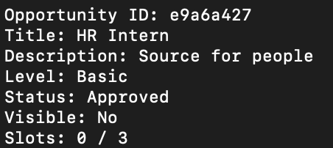  For Non Eligible  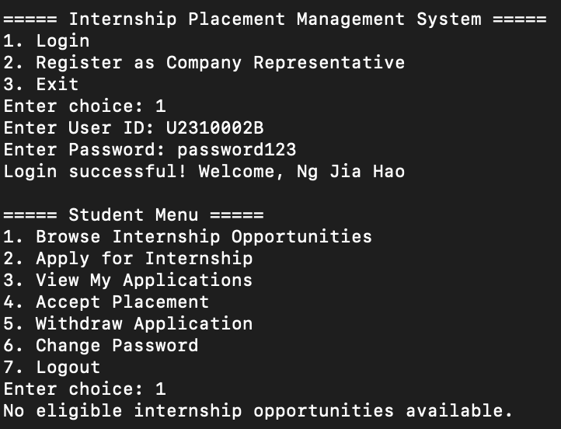  For Eligible:  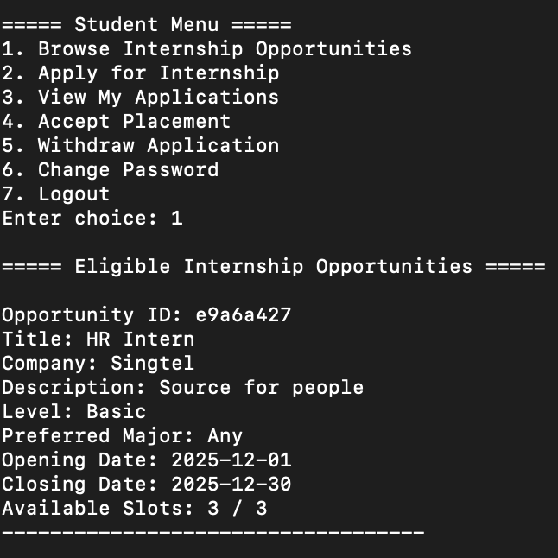
7. Internship Application  Eligibility | Students are able to view eligible internship opportunities and they are then able to apply for the ones they are suitable for | 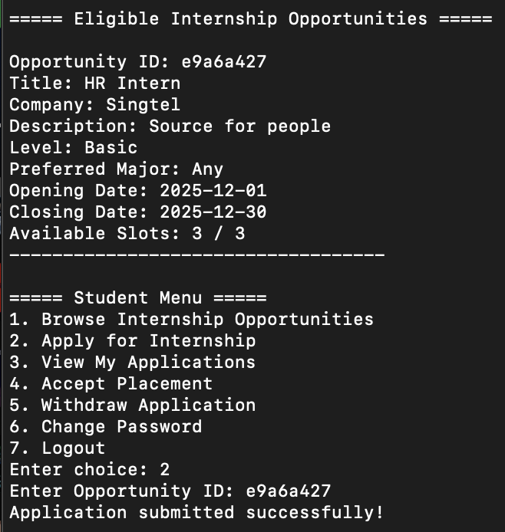
8. Viewing Application  Status after Visibility  Toggle Off | Students are able to view their submitted applications even if the visibility toggle is turned off | 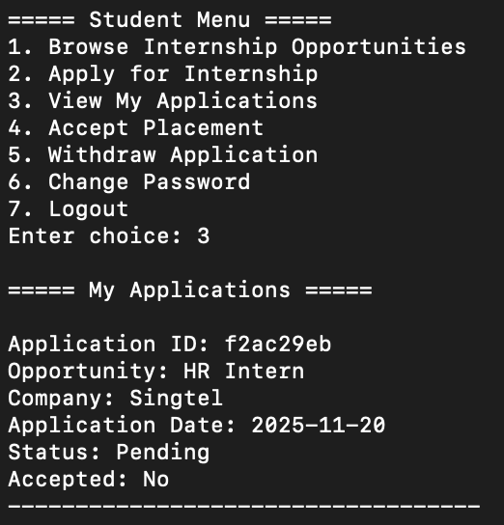
9. Single Internship  Placement Acceptance per  Student | Reject others automatically once a placement is accepted | Approve Student  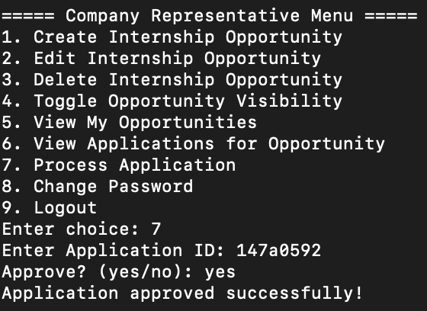  Others Rejectd  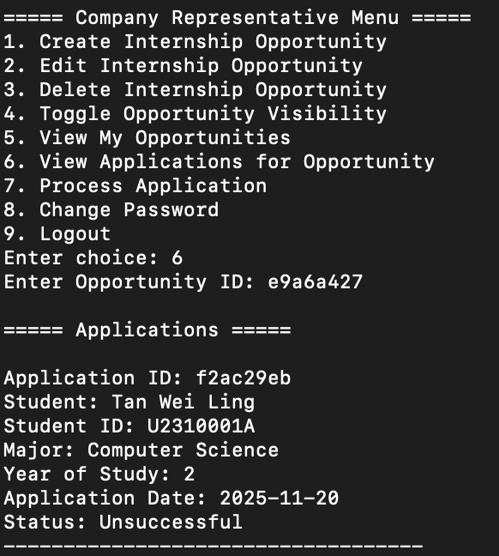
3. Company Representative Creates Internship Opportunity | Company Representative successfully logs in and the system will prompt them for the required details.  Upon successful creation, the system will send a message saying “Opportunity created successfully!. It is pending approval by Career Center Staff.”  [Exception Handling]  If the input is incorrect in either the date format, number format or level, an Error Message “Error: Invalid Input Format” will be displayed  If the Company Representative tries to create a 6th opportunity when they already have 5, an Error Message will be shown | Success  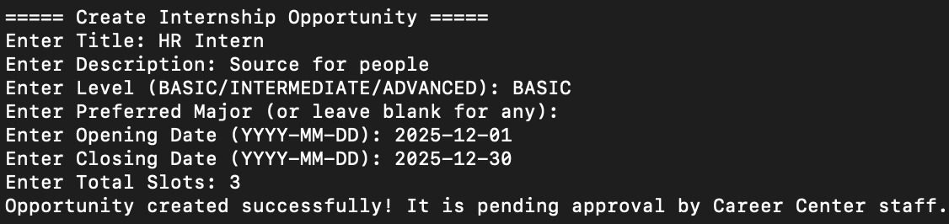  Invalid Input Format  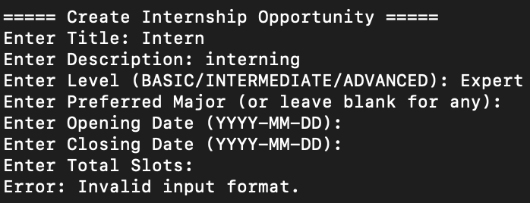  More than 5 Opportunities  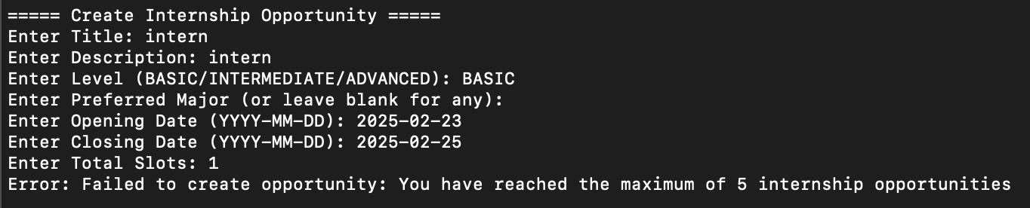
11. Internship Opportunity  Approval Status | Company Representative are able to see which applications are pending and which have already been successfully approved | 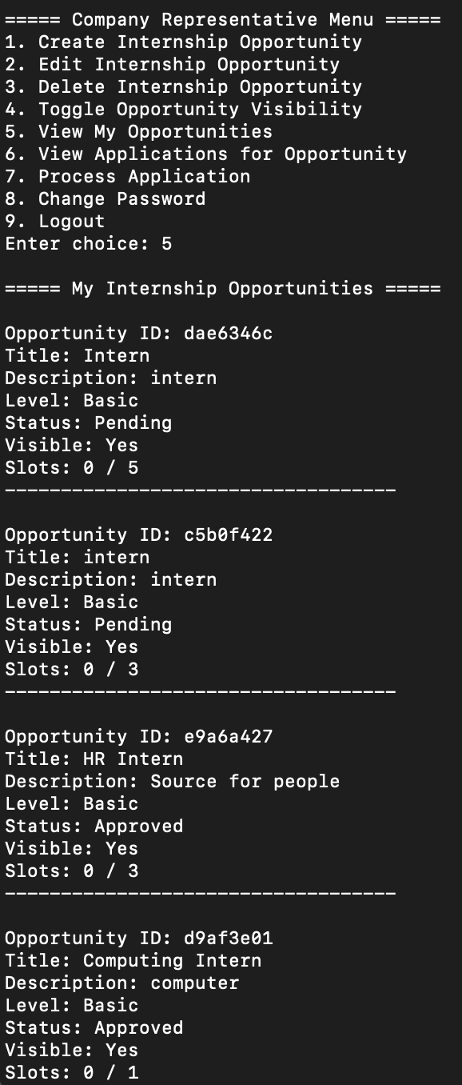
12. Internship Detail Access  for Company  Representative | Company Representative is able to see in their menu even if the visibility is toggled off for students | 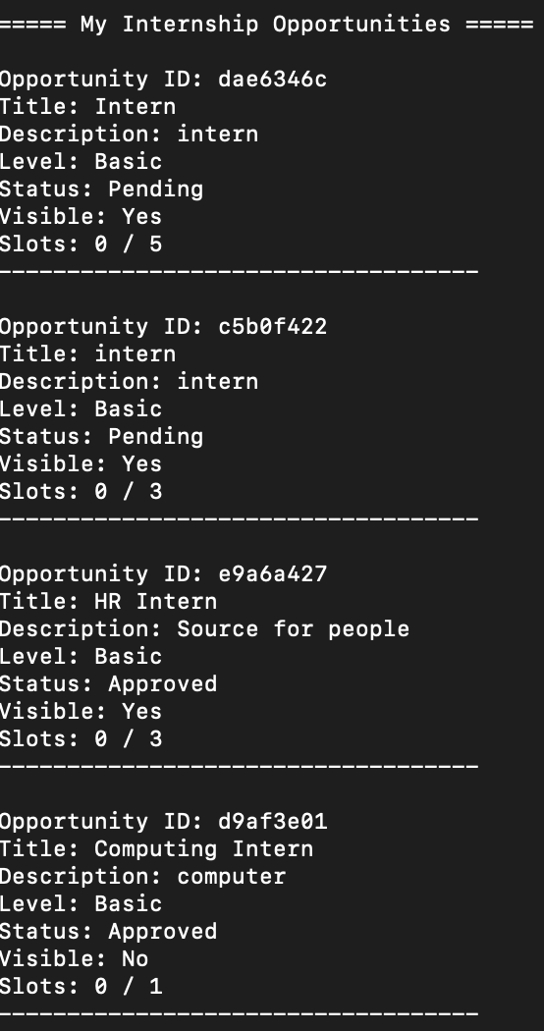
13. Restriction on Editing  Approved Opportunities | Should be able to prevent company rep from editing opportunities that have already been approved by staff | 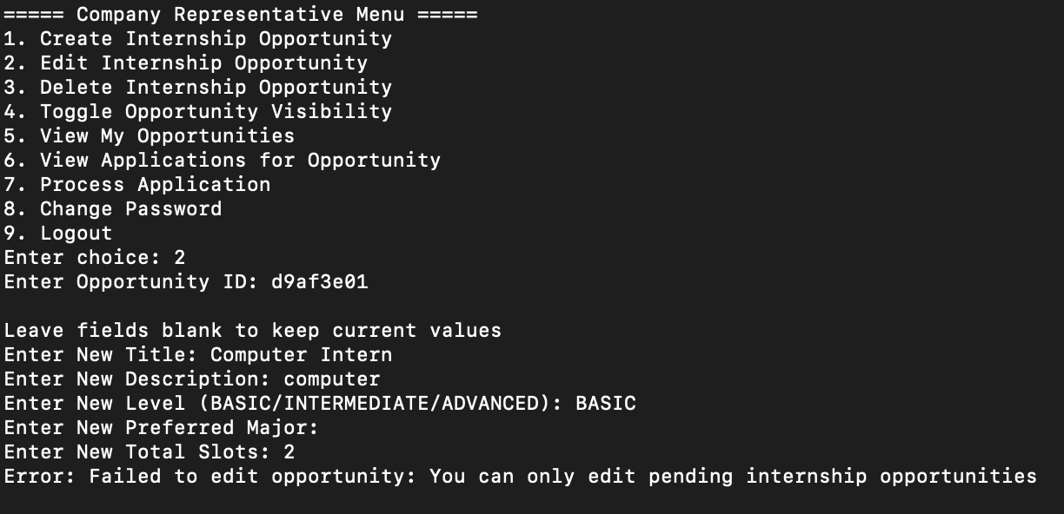
14. Student Application  Management and  Placement  Confirmation | Company reps able to see the updated information based on students acceptance of the position | 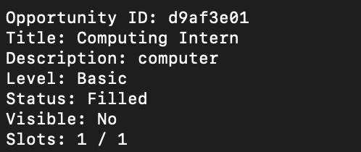
15. Internship Placement  Confirmation Status  Update | Students are able to confirm their successful acceptance which will update the confirmation information and withdraw their other applications | 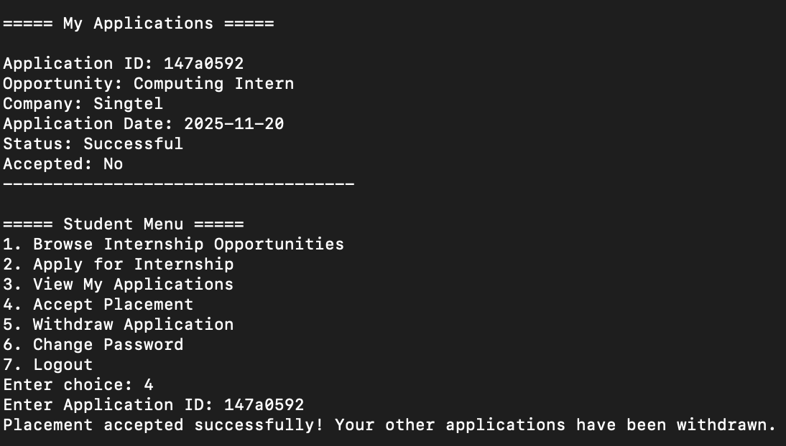
16. Create, Edit, and Delete  Internship Opportunity  Listings | Allow Company Rep to change and modify their opportunities before approval | Before  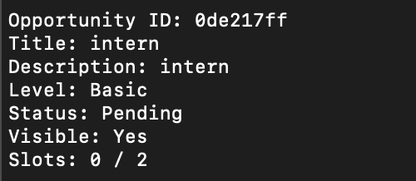  After  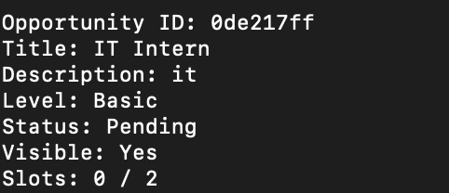
17. Career Center Staff  Internship Opportunity  Approval | Staff are able to view the opportunities requested by company reps and choose whether to approve or reject | Approve  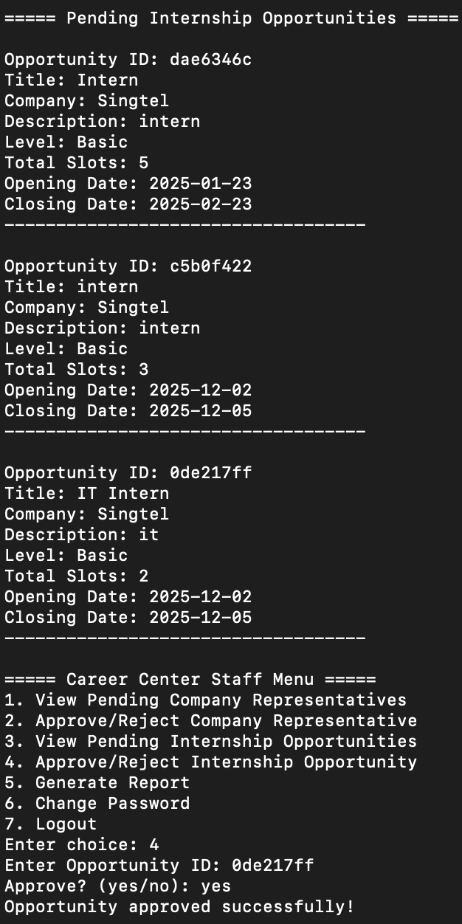  Reject  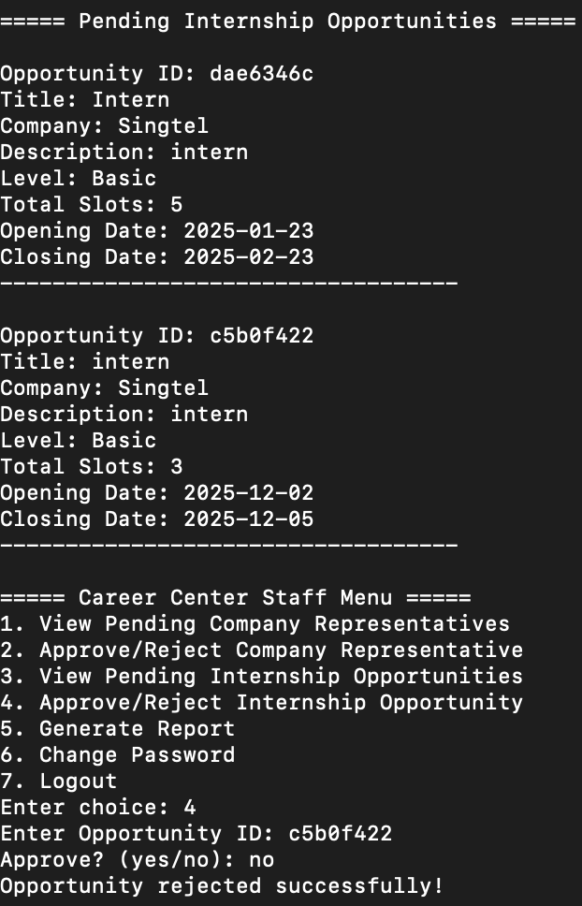
18. Toggle Internship  Opportunity  Visibility | Student should not be able to see opportunities if its toggled off for them | Toggle Visibility for Opportunity  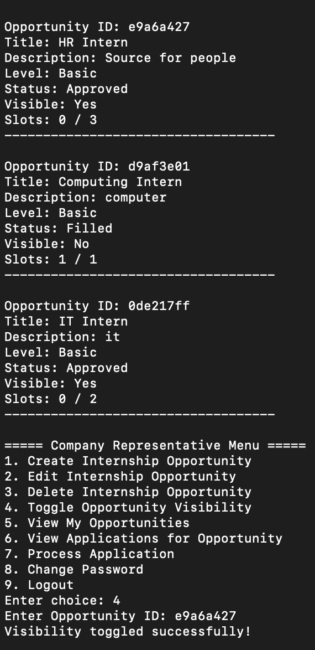  Change Visibility  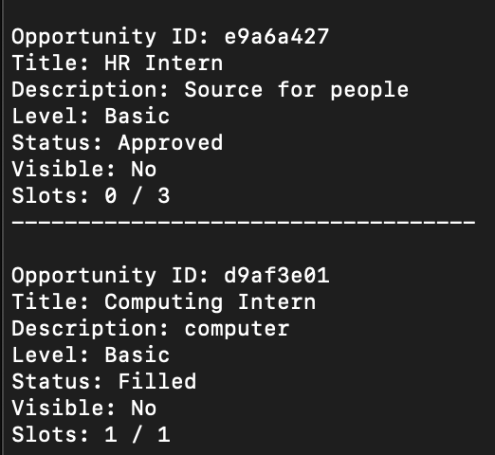  Students are not able to see the opportunities with toggled visibility off  